**Unit 1: Primitive Types**

**Topic 4 Lab 2: Compound Assignment Operators**

|  |  |
| --- | --- |
| **Name:** |  |

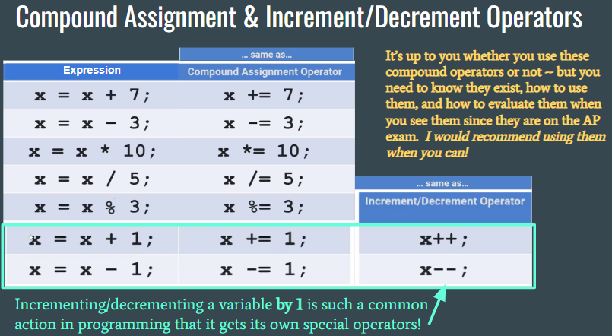

|  |  |  |
| --- | --- | --- |
| **Compound Operators** | | |
| 1. **Below is a simple code segment:**   int x = 6; // line 1  x = x + 4; **// line 2**  System.out.println(x); // line 3  // line 4  int y = 10; // line 5  y = y * 5; **// line 6**  System.out.println(y); // line 7   |  |  | | --- | --- | | **1. REWRITE** *Line 2* and *Line 6* using **compound assignment operators**.  **2.** **TEST** that your rewritten code is correct by copying/pasting the code above, **then** replacing it with your rewritten lines.  **3.** Copy/paste the **rewritten** code to the right: |  |  Check your answers!  1. **Below is a simple code segment that changes two different variables by 1:**   int x = 15; // line 1  x = x + 1; **// line 2**  System.out.println(x); // line 3  // line 4  int y = 20; // line 5  y = y - 1; **// line 6**  System.out.println(y); // line 7   |  |  | | --- | --- | | **1. REWRITE** *Line 2* using the special **increment operator** (+1) and **REWRITE** *Line 6* using the special **decrement operator** (-1)  **2.** **TEST** that your rewritten code is correct by copying/pasting the code above, **then** replacing it with your rewritten lines.  **3.** Copy/paste the **rewritten** code to the right: |  |  Check your answers!  1. **Mentally determine the printed output:** *Write down the variable’s value as it changes!*  |  |  | | --- | --- | | **Code** | **Keep track of variable as it changes:** | | public class Main  {  public static void main(String[] args)  {  int x = 4;  x += 7;  x -= 4;  x++;  x *= 11;  x /= 9 + 1; **// add 9 + 1 *before* dividing!**  x--;  x %= 3;  System.out.println("x = " + x);  }  } | **STARTED FOR YOU!**  x = 4  x = | | | |
| **What gets *printed* above?**  Afterwards, copy/paste/run the code to check! | Explanation | |
| 1. **Mentally determine the printed output:** *Write down the variable’s value as it changes!*  |  |  | | --- | --- | | **Code** | **Track variable:** | | public class Main  {  public static void main(String[] args)  {  // these operators **also** work with doubles!  double y = 5.0;  y *= 4;  y--;  y /= 2;  y %= 4;  y++;  System.out.println("y = " + y);  }  } | **STARTED FOR YOU!**  y = 5.0  y = | | | |
| **What gets *printed* above?**  Afterwards, copy/paste/run the code to check! | Explanation | |
| 1. Complete the **trace table** to help you determine the output when the following code segment executes. *The first few rows are done for you as examples.* Be careful with data types! | | |
| int a = 5;  int b = 7;  double c = a;  double d = c;  b += 2;  a++;  b %= a;  c *= 3 + b;  b++;  d = d + a / b;  c = (a + c) % b;  a += a; | Complete the trace table:   |  |  |  |  | | --- | --- | --- | --- | | **a** | **b** | **c** | **d** | | **5** |  |  |  | |  | **7** |  |  | |  |  | **5.0** |  | |  |  |  | **5.0** | |  | **9** |  |  | |  |  |  |  | |  |  |  |  | |  |  |  |  | |  |  |  |  | |  |  |  |  | |  |  |  |  | |  |  |  |  | | |
| System.out.println("a = " + a);  System.out.println("b = " + b);  System.out.println("c = " + c);  System.out.println("d = " + d); | | **What's the exact output?**  **a =**  **b =**  **c =**  **d =** |
| **Confirm** by copy/pasting the code above into Replit and executing it. | Were you correct? If not, where was your mistake? *Confirm trace table solution & output* | |

|  |
| --- |
| **Freestyle!** Write a program of your choice that involves a user entering textual **and** numerical input in a meaningful way (totally up to you what you ask for). Use nextLine, nextInt, and/or nextDouble as you see fit.  Somewhere in your program, you should **also** include:   * The use of at least one **compound assignment operator** * The use of at least one i**ncrement/decrement** operator * The use of at least one if-else statement or if statement (without the else)   Let the creative juices flow and have fun 😁 |
| **Copy your program’s code from Coding Rooms and paste it below:**  (use the Courier New font for code-style!) |

|  |  |  |  |
| --- | --- | --- | --- |
| **Share your program with your partner and get some feedback!**  Let your partner run your freestyle program and check out your code! Give and receive a piece of feedback. | My partner's name:   |  | | --- | |  |   A piece of feedback my partner gave me:   |  | | --- | |  | |

**Done!**

Submit in Google Classroom:



**Now complete the U1T1-U1T4 AP Practice Questions in Google Classroom**

(15 Multiple Choice x 4 points each)

*You should discuss answers with your partner and classmates before you submit!*

### Trace Table (back)

|  |  |
| --- | --- |
|  | |
| int a = 5;  int b = 7;  double c = a;  double d = c;  b += 2;  a++;  b %= a;  c *= 3 + b;  b++;  d = d + a / b;  c = (a + c) % b;  a += a; **(same as a = a + a)** | Red = value changed *after* executing that line   |  |  |  |  | | --- | --- | --- | --- | | **a** | **b** | **c** | **d** | | **5** |  |  |  | |  | **7** |  |  | |  |  | **5.0** |  | |  |  |  | **5.0** | |  | **9** |  |  | | **6** |  |  |  | |  | **3** |  |  | |  |  | **30.0** |  | |  | **4** |  |  | |  |  |  | **6.0** | |  |  | **0.0** |  | | **12** |  |  |  | |
| **Exact printed output:**  System.out.println("a = " + a);  System.out.println("b = " + b);  System.out.println("c = " + c);  System.out.println("d = " + d); | |

### Answer (back)

|  |  |
| --- | --- |
| **What gets *printed* above?** | **x = 1** |

|  |  |
| --- | --- |
| public class Main  {  public static void main(String[] args)  {  int x = 4;  x += 7;  x -= 4;  x++;  x *= 11;  x /= 9 + 1; **// add 9 + 1 *before* dividing!**  x--;  x %= 3;  System.out.println("x = " + x);  }  } | x = 4  x = 11  x = 7  x = 8  x = 88  x = 8  x = 7  x = 1  **x = 1** |

**DETAILS:**



### Answer (back)

|  |  |
| --- | --- |
| **What gets *printed* above?** | **y = 2.5** |

|  |  |
| --- | --- |
| public class Main  {  public static void main(String[] args)  {  // these operators **also** work with doubles!  double y = 5.0;  y *= 4;  y--;  y /= 2;  y %= 4;  y++;  System.out.println("y = " + y);  }  } | **STARTED FOR YOU!**  y = 5.0  y = 20.0  y = 19.0  y = 9.5  y = 1.5  y = 2.5  **y = 2.5** |

**DETAILS:**



### Check (back)



### Check (back)

